

PIPELINE ROW PATROL INSPECTION REPORT

**Enstor  
  
Katy Pipelines**

June 16, 2025

**CONFIDENTIAL DOCUMENTS**

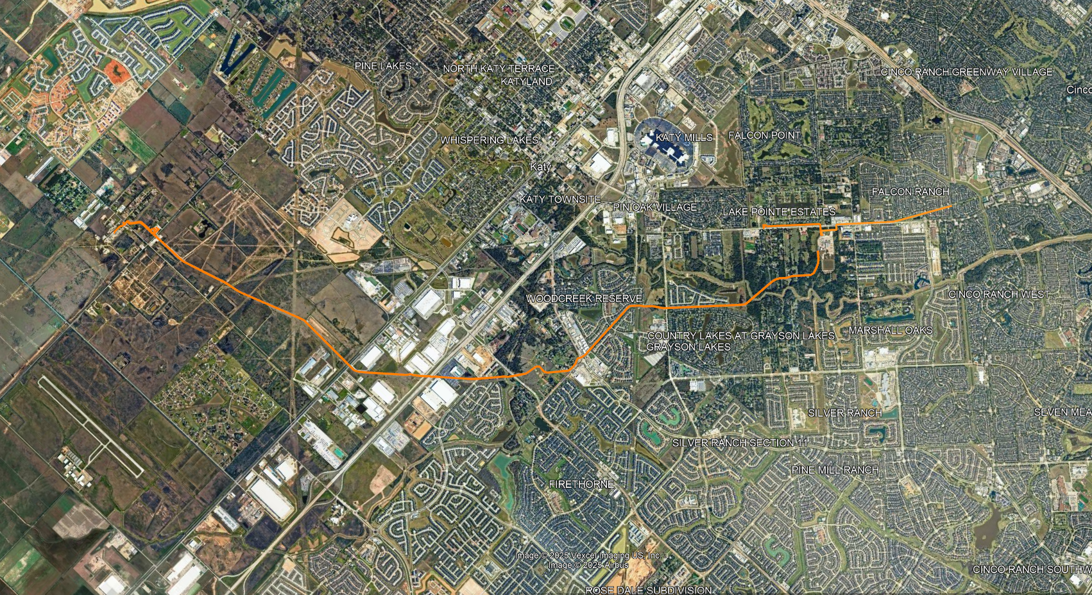

Arch Aerial, LLC

3801 Yale Street

Houston, TX 77018

281.974.5752